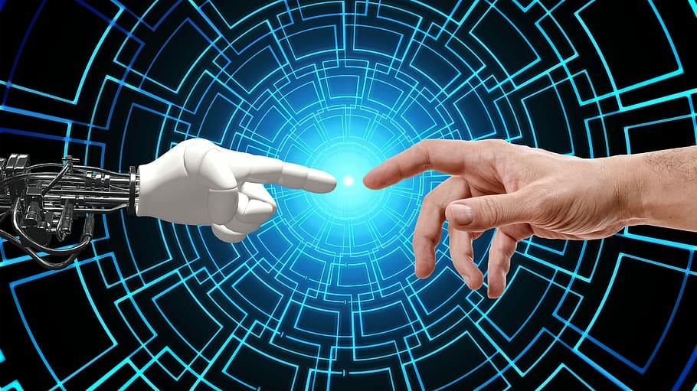

BIONIC HAND

Tele-operated using flexi sensors

Team Name: The Trailblazers

Submission Date: 06/07/23

**Project Start Date:** 01/10/22

**Project Finish Date:** 22/06/23

GROUP F

Clayton D’ Gama (7242293)

Suraksha Kotte (6996656)

Saharsh Madassery (6922764)

Mohamed Jalal Abuklal (5902514)

|  |
| --- |
|  |

**Table of Contents**

1. Quality of Executive Brief 4

2. Project Details 4

2.1 Definition 4

2.2 Objectives 4

2.3 Deliverables 4

3. Design Details 5

3.1 Hardware 5

3.2 Software 10

4. Design Iterations 10

4.1 Objectives/ Goals 11

4.2 Methodology 12

4.3 Roles and Actions taken 13

4.4 Challenges 14

4.5 Outcomes 15

4.6 Critical discussion 16

4.6.1 Strengths 16

4.6.2 Weaknesses 16

4.6.3 Additional Considerations 17

5. Testing Procedure 18

5.1 Testing of Individual Components: 18

5.1.1 Arduino Uno 18

5.1.2 Wires 19

5.1.3 Sensor Shield 19

5.1.4 Flexi Sensors 19

5.1.5 Servo motors 19

5.2 Final Testing and Alpha Testing Completion: 19

6. Results 20

6.1 Presentation of Results 20

6.2 Analysis 20

6.3 Discussion of results 21

7. Critical Discussion 22

7.1 Design 22

7.2 Feasibility 23

8. Statement on Achievements 24

9. Recommendations 25

10. Attainment of Objectives 26

11. Appendix 26

11.1 Appendix A: Gantt Chart 26

11.1.1 Autumn Semester 2022 26

11.1.2 Winter Semester 2023 27

11.1.3 Spring Semester 2023 27

11.2 Appendix B: Minutes of Meeting 27

11.3 Appendix C: Division of Labor 32

11.4 Appendix D: Software Code 33

12. References 36

# Quality of Executive Brief

A Bionic hand using a 3D-printer was made to look like a human hand using Flexi sensors that are worn with gloves and read the movement of each of the five fingers. These bionic hand reading data represent the position of the finger joints with the rotating movement for each one. The five servo motors that power the hand's fingers are controlled by an Arduino microcontroller.

Since all necessary components can be 3D printed, the hand is both affordable and widely available. A hand's abilities include also grasping and releasing objects, pointing, and moving the fingers. The hand can be used in a variety of situations, such as assisting doctors during surgical procedures and remotely disarming a bomb, because it is much safer than risking human life.

# Project Details

## Definition

The bionic hand is a mechanical device that simulates the flexibility and dexterity of human hands. It is frequently implemented in robotics applications to carry out a variety of tasks that call for deft manipulation and strong grasping abilities. A bionic hand's main function is to imitate human hand movements so that it can interact with objects and carry out tasks similarly. A bionic hand is made up of numerous fingers, joints, and actuators that enable it to perform a variety of motions and grasp objects of different sizes, shapes, and weights. A glove is connected with the fingers and contains sensors to provide tactile feedback and feedback on position to allow the hand to interact with the environment and objects with a certain level of perception.

## Objectives

A bionic hand has the capacity to recognize and comprehend the characteristics of the various objects it interacts with. It includes characteristics that aid in the hand's effective manipulation of the object, such as shape, size, texture, and weight. The robotic hand typically uses a variety of sensors, including force sensors, tactile sensors, depth sensors, and more to achieve object clarity. These sensors give the control system feedback, allowing the hand to modify its grasp and manipulation techniques according to the properties of the object.

## Deliverables

The deliverables of a bionic hand depend on the application and design requirements, such as:

1. The bionic hand prototype comes with a thorough mechanical design of the hand that details its structure, components, and materials. Power calculations for finger movement, technical drawings, and 3D-printed components have all been developed and used.

1. A bionic hand has the ability to grasp and control objects of various weights, sizes, and shapes. It has the capacity to modify its grasp in order to effectively carry out a variety of tasks and hold objects securely.

1. The bionic hand is as dexterous as a human hand, allowing it to carry out complex and precise movements. It includes the capacity to perform tasks requiring fine motor skills, as well as individual finger control, coordinated movements, and other skills.

1. Sensors are integrated with the bionic hand to give real-time feedback on the objects being moved. This feedback enables the bionic hand to fine-tune its grip, amount of force, and movement to precisely interact with objects and avoid slippage or damage.

1. The bionic hand has sustained performance evaluation tests to evaluate its capabilities, including gauging its robustness, accuracy, and speed of grasping. To ensure that every component is functional and performing its function perfectly, tests have been performed on the prototyped hand.

# Design Details

## Hardware

Understanding our project's constraints and intended mobility with the professor's direction helped us decide on a more realistic hand with human-like flexibility of motion and range after multiple sessions. To make the arm match human movement, joints, finger flexing, and minute palm motions would have to be replicated.

We evaluated various choices that might be a suitable fit for our project based on our amended requirements. When choosing a hand, we examined cost, mechanism, durability, and reliability.

InMoov struck out during our investigation since they offer a big library of open-source 3-D printed mechanical parts, enough to create a whole robot. According to the company description, "InMoov is a humanoid robot controlled by Arduino microcontrollers and built from 3D printed plastic body components."[4] We determined that merely printing the head from the full robot was enough to fulfil our needs.

* + 1. Design models

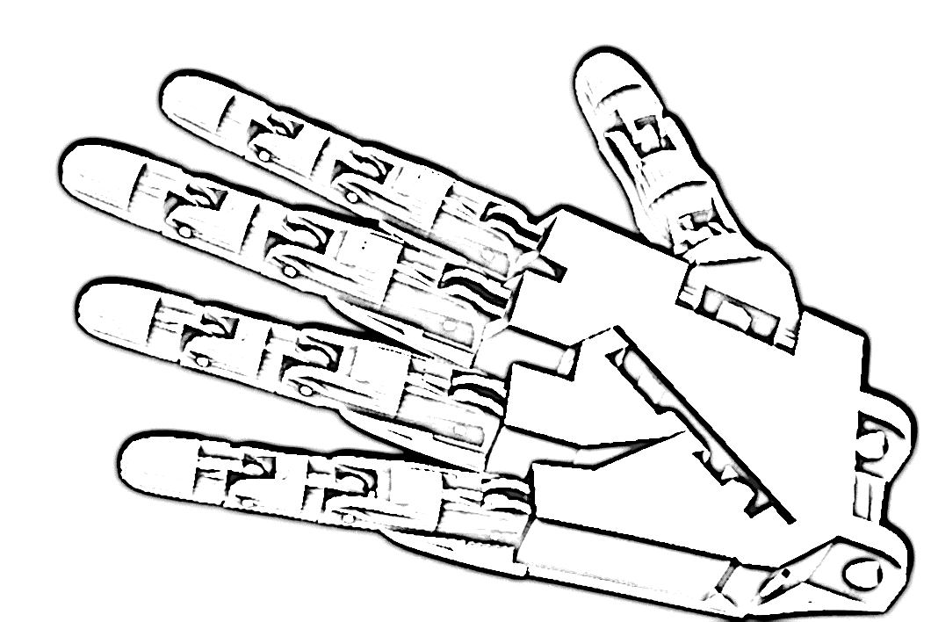

*Fig 1: Hand model* [20]

*Fig 2: Finger model* [21]

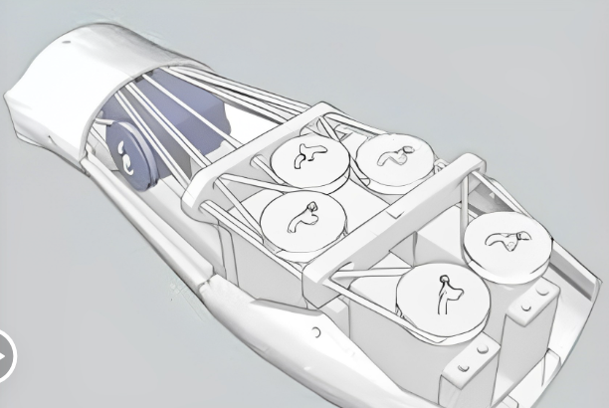

*Fig 3: Arm with servo motors*

*Fig 7: angles of movement*

The fingers are linked via three pulleys which will be placed at the finger joints, which are:

* DIP, which is Theta 1 and has a maximum bending angle of 30 degrees.
* PIP, which is Theta 2 and has a maximum bending angle of 90 degrees.
* MCP, which is Theta 3 and has a maximum bending angle of 90 degrees.

Each pulley is connected by a fishing wire wrapped around it that is 6 times the circumference of the pulley because we need the wire on both sides of the pulley to control the joints and prevent the fingers from falling off due to the lack of tension.

* + 1. **Final designs:**

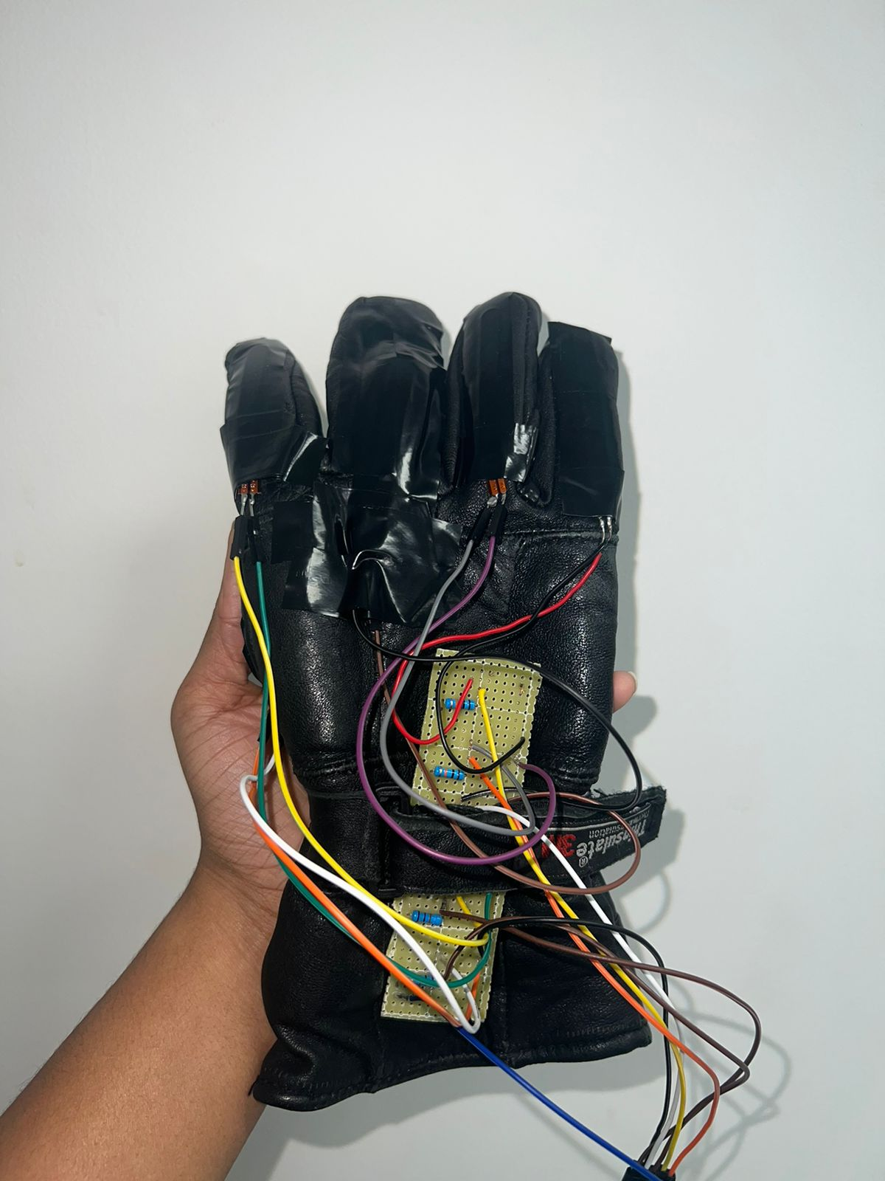

*Fig 4: final flexi- sensor glove*

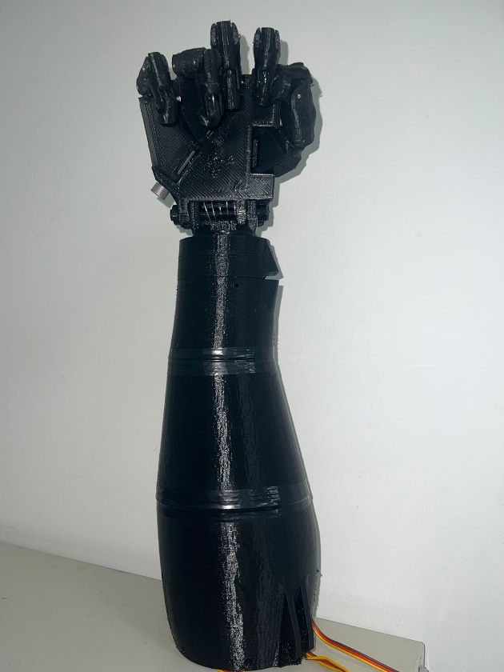

*Fig 5: final design*

*Fig 6: final design with the servo motors*

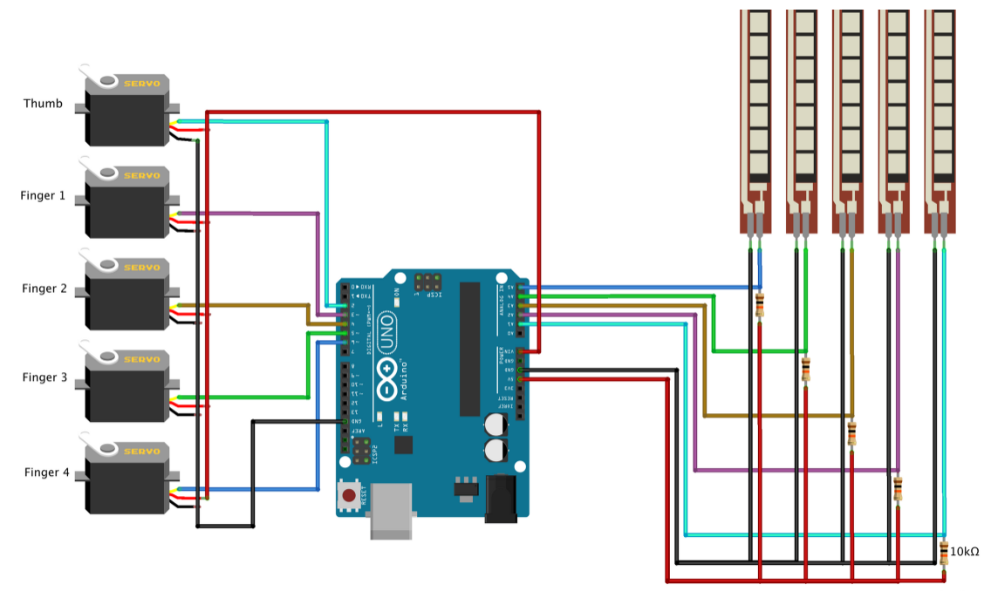

*Fig 8: Tinker CAD Circuit*

The above circuit shows the connections of the flexi sensors to the Arduino which is connected to the 5 servo motors.

## Software

*Fig 9: Software flowchart*

The flowchart above shows how hand motion is detected on the Bionic arm. We first start and initialize the Arduino, then the Arduino checks if the flex sensor is bent if no it keeps looping until bend on the flex sensor is detected, after detection it calculates how much the flex sensor is bent and resembles the similar motion on the Bionic hands' fingers with the help of servo motors until desired position is met.

# Design Iterations

**First Iteration:**

* Design and 3D-print the bionic hand's fundamental structure in the first iteration.
* Flexi sensors should be stitched onto a glove to provide optimal positioning for tracking finger movements.
* Servo motors and the Arduino microcontroller should be connected with flexi sensors.
* To read flexi sensor signals and regulate finger movements, write the initial code on Arduino.
* Examine the synchronization of finger movements and flex sensor inputs and results of them work together.
* Check the prototype's usability and note its problems and defects.

**Second Iteration:**

* On the basis of the arm movements, improve the 3D-printed foundation construction with more Infill density to provide it with more strength.
* For improved functionality and durability, use braided fishing lines as tendons into the design of the finger mechanics.
* To make sure that finger movements are light and economical with energy, optimize the pulley and add gears onto the motor system.
* Improve the flexi sensors calibration and sensitivity by changing the resistor values to more precisely detect finger movements.
* Change the code to permit adjusting the pace of the arm movements.
* To assess the Bionic arms performance, and durability, carry out rigorous testing.

**Third Iteration:**

* Develop the design further depending on comments and needs from the professors.
* The software code, flexi sensors, and finger mechanics should all be improved as needed.
* Conduct extensive usability and functionality testing the arm to real world activities such as grabbing or holding something.
* By improving power management and including another Power supply, to make the bionic hand work without it Jittering.
* Complete the manufacturing, documentation, and design procedures for upcoming production.

## Objectives/ Goals

Our primary goal is to make sure our bionic hand is ready and fully operational by the time of presentation. It also should adhere to our Main objective which is to move naturally like a human hand while still being used for teleoperation. The benefits of this bionic hand are improved usage, reduced cost, and more versatility. Its versatility makes it simple to modify to a range of tasks and use situations. Due to its versatility and affordability, it is ideal for use in military and medical applications.

The following are the project's objectives and goals:

1. Complete assembling the arm and is fully Operational In time of the Deadline.
2. Move each finger according to the user’s fingers movement and match it.
3. Find methods to stop the arm from gitterning and come up with a Solution for this Problem.
4. Find a solution to provide enough current to the motor as the Sensor shield was not provided.
5. Calibrate each of the flexi sensors.
6. Transfer the flexi sensor circuit from the breadboard and replace it on the Perfaboard to manage space and look more presentable.

## Methodology

The redesigned bionic hand prototype's process takes a methodical, iterative approach. Starting with a review of the requirements, it defines goals including modularity, adaptability, and cost. The construction of the design is integrated and flexible thanks to 3D printing technology. Finger movements are tracked using glove-integrated flexi sensors, which are translated by an Arduino Uno microcontroller. Servo motors attached to fishing lines control the hand's motion to enable different finger movement.

Functionality, dependability, and customization are improved through careful testing, user input, and adjustments. In addition to considering usability, portability, and power management, documentation is created for future growth. Overall, the process guarantees a prototype bionic hand that is well-designed and adaptable.

The bionic hand prototype is being tested using an approach that combines the Waterfall model with particular testing techniques. A systematic and thorough testing strategy is maintained throughout the development phases thanks to the waterfall methodology. On the software side, unit testing checks certain software components, white box testing examines the code structure and logic, black box testing tests the functionality of the system as a whole, and system testing tests the whole software system.

Hardware testing comprises mechanical testing to evaluate the sturdiness of the hand, electrical testing to evaluate the dependability of the wiring and connections, and overall system testing to ensure smooth integration. To guarantee that the hand satisfies user requirements, remains free of new faults, performs properly, and complies with security standards, acceptance testing, regression testing, performance testing, and security testing were carried out. This approach guarantees an exhaustive and trustworthy testing procedure for the bionic hand prototype.

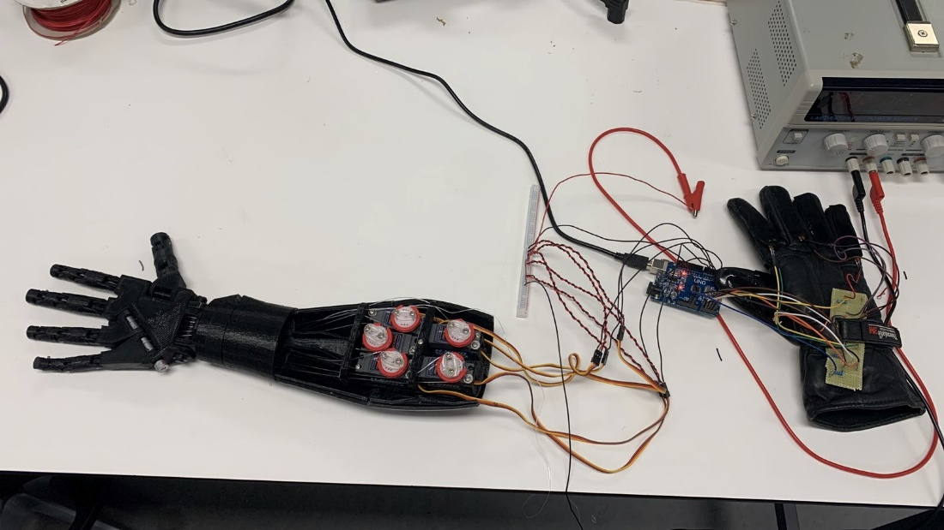

*Fig 10: bionic hand prototype*

## Roles and Actions taken

Throughout the Bionic Hand's design iterations, our engineering team took several kinds of steps to ensure the effective development and installation of this teleoperated device. Each team member was vital in this process. The tasks that need to be performed and the team member roles allocated to solve the difficulties are outlined below:

1. Research:

Mohamed played an important role in doing comprehensive research on bionic hand technologies, flexi sensors, and teleoperation systems. He acquired useful information about current designs, examined technical requirements, and investigated prospective applications. Mohamed's contribution was critical in conceptualizing a preliminary design scheme based on flexi sensor capabilities.

1. System Integration:

Clayton was in charge of setting up the Bionic Hand's overall system framework. He worked closely with Suraksha and Saharsh to incorporate flexi sensors and enable seamless connection with the remote operation method. Clayton's knowledge in system design and integration was crucial in creating a unified and effective product.

1. Mechanical Design:

Clayton was in charge of the Bionic Hand's mechanical design. He turned the initial design into a precise 3D printed model, taking into consideration characteristics like range of movement and grip strength.

1. Calibration and Integration of Sensors:

Suraksha worked on incorporating mechanical and flexi sensors into the Bionic Hand. She chose appropriate sensor types, developed sensor interface circuits, and integrated them into the entire electronic system. Her sensor integration skills were critical in ensuring accurate and responsive teleoperation.

1. Software Development:

Saharsh created the Bionic Hand's software and control system. He developed algorithms that analyzed sensor data, converted it into hand motions, and provided real-time control. His role also included fine-tuning the control positions to ensure dependable functioning.

The team maintained open communication, regularly exchanging ideas and sharing progress updates. This collaborative approach allowed for effective problem-solving and quick resolution of design challenges.

## Challenges

During the design iteration process, we encountered several issues, the most significant of which were as follows:

1. Sensor Accuracy and Calibration:

Challenge faced: When calibrating the flexi sensors, the readings were not exact, and it was occasionally not recognized. One of the major issues encountered was sensor calibration, which is required for correct hand motions.

Solution: We performed multiple calibration tests on various hand sizes and tuned the sensor parameters. We correctly captured sensor responses and examined the acquired data. We were able to discover any systematic errors or non-linearities in sensor values that required calibration modifications by examining the data. We improved sensor accuracy and teleoperation reliability via repeated testing and adjustment.

1. 3D printing:

Challenge faced: One of the difficulties we encountered was getting access to and using the 3D printing equipment offered at our university. While the machine was a tremendous resource for producing complicated parts, it also offered some challenges that needed to be overcome. We reprinted the majority of the sections multiple times since they did not print accurately or encountered machine difficulties.

Solution: To guarantee that we had access to the machine when we wanted it, we worked with the lab assistant in charge to optimize our printing schedule. We reduced delays and increased machine utilization by actively planning and managing our printing needs. We ran extensive tests, such as file validity and repair, to resolve any errors that could have an impact on the printing process. We also adjusted the designs for printing efficiency, modifying factors like thickness to create effective prints within the limits of the device.

1. Real-Time Responsiveness:

Challenge faced: ensuring real-time control, since any delay in hand movements could negatively impact user experience and performance. We detected at least 3-4 seconds of latency when conducting our several tests.

Solution: We constantly developed and optimized the control algorithms that translate sensor inputs into hand movements. We lowered computing time without sacrificing accuracy by simplifying the algorithms. This enhancement enabled quicker and more responsive control of the Bionic Hand. We did comprehensive hardware testing to certify the teleoperation system's real-time responsiveness. This entailed connecting the hardware with the programming software and verifying the system under different circumstances and stress situations. We detected and rectified any performance issues that may impede real-time response through iterative testing and optimization.

## Outcomes

Our project has yielded impactful outcomes, contributing to both our personal development and the advancement of knowledge in the field of robotics. We are proud to highlight the significant achievements we have accomplished together.

First and foremost, a key outcome of our project is the successful development of a teleoperation system for the InMoov bionic hand. Through our collective efforts, we integrated a Flexi sensor-embedded glove that serves as an intuitive and natural control interface. This achievement has greatly enhanced the user experience and made operating the InMoov hand more accessible and user-friendly.

In addition, we have achieved realistic hand movement by accurately mapping the Flexi sensor readings to the degree of rotation of the hand's motors. This level of precision in replication is crucial for applications that require fine motor control and dexterity. We diligently ensured the accuracy of the mapping process, considering individual variations in finger joint movement. As a result, the InMoov hand exhibits lifelike and natural movements.

Affordability and accessibility are also notable outcomes of our project. By integrating off-the-shelf components such as Flexi sensors, servo motors, and Arduino platforms, we have developed a cost-effective solution that falls within a reasonable range for potential users.

While our project has achieved significant success, it has also revealed important areas for improvement. We have identified weaknesses in our teleoperation system, including limited sensory feedback, calibration challenges, and mechanical constraints. Acknowledging these areas for improvement, we are committed to addressing them through enhancements in sensory feedback mechanisms, calibration methods, and exploring alternative actuation mechanisms. By recognizing these shortcomings, we aim to improve the overall performance and usability of our system.

Overall, the outcomes of our project have been substantial. We have successfully developed a teleoperation system that offers intuitive control, realistic hand movements, and affordability. Additionally, we have identified areas for improvement, showcasing our dedication to continuous development and refinement. As a group, we take pride in what we have achieved and are excited about the potential impact our work can have in the field of robotics.

## Critical discussion

This teleoperation based system developed for the InMoov hand, utilizing a Flexi sensor-embedded glove, below are several strengths and weaknesses that need to be carefully weighed to assess its overall effectiveness. In this section, we will examine those aspects, considering various relevant issues and viewpoints.

### Strengths

1. Intuitive Control: One of the key strengths of the teleoperation system is its use of a glove with Flexi sensors, enabling an intuitive and natural control interface. Users can replicate their hand movements to operate the InMoov hand, enhancing the user experience and facilitating ease of use. However, it is important to consider the learning curve for new users who may require time to adapt to the control mechanism.
2. Realistic Hand Movements: The teleoperation system successfully maps the Flexi sensor readings to the degree of rotation of the motors, allowing it to replicate human hand movements with a reasonable level of accuracy. This capability is vital for applications requiring fine motor control and dexterity. However, it is important to note that the mapping process may need fine-tuning to account for individual variations in finger joint movement, ensuring accurate replication.
3. Low-Cost Hardware: The integration of off-the-shelf components, such as Flexi sensors, servo motors, and Arduino platforms, result in a comparatively affordable teleoperation system compared to more advanced alternatives. This aspect increases availability and affordability for potential users. Additionally, the availability of open-source designs and tutorials lead to a vibrant community that can offer support and further improvements.

### Weaknesses

1. Limited Sensory Feedback: One of the primary weaknesses of the current teleoperation system is the lack of sufficient sensory feedback to provide user with a realistic sense of touch and force feedback. This limitation can affect the user's ability to do delicate task and may result in reduced precision. Integrating additional sensors or haptic feedback mechanisms could address this weakness and enhance the user's sense of touch and perception. Integrating additional sensors or haptic feedback mechanisms could address this weakness and enhance the user's sense of touch and perception.
2. Calibration and Individual Variations: The calibration process for mapping Flexi sensor readings to motor rotation degrees is crucial but can be challenging. Individual variations in hand anatomy, such as finger length or joint flexibility, and sensor placement may affect the accuracy of the mapping, leading to inconsistencies between users. Conducting thorough calibration procedures for each user and investigating adaptive calibration techniques can improve the system's accuracy and adaptability.
3. Mechanical Constraints: The teleoperation system relies on fishing lines as tendons and servo motors for actuation, which introduces mechanical constraints. The use of fishing lines may result in non-linear responses and imprecise control, while the limitations of the servo motors may restrict the range of hand movements achievable. Exploring alternative actuation mechanisms, such as soft actuators or pneumatic systems, could potentially overcome these limitations and provide a more flexible and precise control of the hand.

### Additional Considerations

1. Ergonomics and User Comfort: It is essential to consider the ergonomic design and comfort of the glove and InMoov hand to ensure prolonged use without causing discomfort or fatigue. Evaluating the impact on user experience, conducting user feedback sessions, and addressing any potential ergonomic issues is crucial for long-term usability and user satisfaction.
2. Scalability and Generalizability: The developed teleoperation system should be evaluated in terms of its scalability to accommodate different hand sizes and configurations. Additionally, assessing the generalizability of the system to other robotic platforms or teleoperation tasks is important to determine its broader applicability. Addressing modularity and adaptability during system design can facilitate scalability and generalizability.
3. Safety and Reliability: The teleoperation system must be assessed for safety and reliability aspects, especially in critical applications. Robust fail-safe mechanisms, real-time monitoring, and error handling protocols should be implemented to minimize the risks associated with hardware failures or communication issues. Conducting thorough risk assessments and adhering to relevant safety standards are paramount.

In conclusion, while the teleoperation system utilizing the Flexi sensor-embedded glove for the InMoov hand offers intuitive control and realistic hand movements, it also exhibits limitations concerning sensory feedback, calibration, and mechanical constraints. Addressing these weaknesses through enhancements in sensory feedback, calibration methods, and mechanical design can improve the overall performance and usability of the system.

# Testing Procedure

This part of the report provides an overview of our test procedure and highlights the successful completion of the tests, confirming the functionality of our system and its individual components. Prior to evaluating the system as a whole, we conduct a thorough examination of the physical components, such as the Flexi glove and the hand.

**Components:**

* Arduino Uno
* Servo motors
* Flexi sensors
* Wires

To ensure comprehensive testing, we adopted the V model testing strategy, which emphasizes verification and validation throughout the development life cycle.

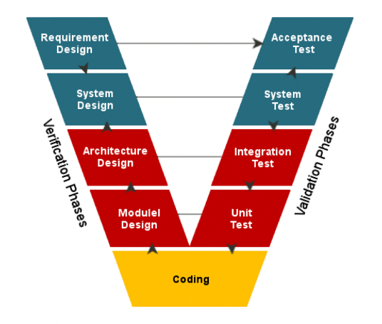

*Fig 11: V model [3]*

Verification and validation are vital for system and software development, and the V model was specifically designed to address these aspects in testing. It illustrates the relationship between each stage of the development life cycle and the subsequent testing phase.

## Testing of Individual Components:

### Arduino Uno

Test Description:

* Communication Port Check Connect the Arduino to a computer and verify successful detection and the ability to write to the Arduino.
* Pin Port Check Connect pin 1 to pin 2, designate one as an input and the other as an output. Verify successful communication and repeat the process vice versa for all pins.

### Wires

Test Description:

* Wire Continuity Check Using a multimeter, place one test probe on one end of the wire and the other probe on the opposite end. If the resistance test returns 0, the wire is intact. Additionally, check if a current can be transmitted through the wire to ensure no breaks.

### Sensor Shield

Test Description:

* Operational Port Check Plug a servo into each port and verify if the servo functions properly.

### Flexi Sensors

Test Description:

* Accuracy of Readings After setting up the Flexi sensors, measure the calculated distance obtained from the sensors and compare it to the actual distance between readings of the hand.

### Servo motors

Test Description:

* Angle Rotation Accuracy Test the ability of the servo to rotate to accurate angles. Connect the servo to the Arduino via the shield and program it to move to various angles. Compare the programmed angles to the actual movement degrees.

## Final Testing and Alpha Testing Completion:

The final stage involved testing the complete system after integrating all the components. This comprehensive testing evaluated the user experience and the overall quality of the product. By following the established testing procedures and adopting the V model, we meticulously examined the entire system, including its integrated components.

As this project is a university undertaking and not intended for mass manufacturing, the final testing stage can be classified as alpha testing. It involved replicating user actions and documenting the outcomes, allowing us to thoroughly assess the system's behavior and address any potential issues.

By successfully completing the testing procedures outlined above, including the alpha testing phase, we have confirmed the proper functioning of our system and its components, including the Flexi glove and the hand. These tests ensure that our project meets the desired standards and requirements, providing valuable insights for further refinement and enhancement.

# Results

## Presentation of Results

The Bionic hand was developed using open-source hardware and software and is programmable in a variety of programming languages. Servomotors give the hand its ability to move and grasp objects. Its five fingers each have three joints. The results of the artificial hand can be divided into three categories: hardware, software, and performance.

Hardware: The hardware components include the servo motors, gears, bearings, fishing wires, and 3D-printed parts that make up the Bionic hand. The quality and precision of these components will have a substantial impact on the hand's overall effectiveness. We may evaluate the hardware by looking at things like the servomotors' accuracy, the bearings' and gears' durability, and the quality of the 3D-printed parts. A braided fishing line that is attached to a fully functional pulley system that is connected to the motors and has a torque of up to 7N connects the gears. The hand may operate poorly or perhaps fail if one or more of these components isn't working properly.

Software: Servo motors are used, and they also evaluate sensor data. When evaluating the program, one can take into account the motion precision, the hand's responsiveness to input, and the software's adaptability. Complicated tasks might be difficult to finish if the program is slow or unresponsive, which can lead to errors in movement. It is assumed that the Bionic hand will be set up and that a Flexi sensor will be connected to an analog port on the microcontroller board. The code receives the value from the Flexi sensor and converts it to a value between the minimum and maximum pulse widths of the hand servo. The hand servo is then moved using the mapped value. The loop constantly iterates, allowing the servo motors attached to each finger to respond quickly to changes in the Flexi sensor Value.

## Analysis

The servomotors, gears, bearings, and 3D-printed pieces that make up the Bionic hand are among the mechanical parts. The efficiency of the hand as a whole will be significantly influenced by the caliber and accuracy of these parts. We may assess the hardware by considering factors like the precision of the servo motor, the robustness of the bearings and gearboxes, and the caliber of the 3D-printed components.

The gears are connected by a braided fishing line that is fastened to a fully operational pulley system that is connected to the motors and has a torque of up to 7N. If any of these parts aren't functioning properly, the hand may perform poorly or even fail.

Servo motors are employed, and they analyze sensor data as well. One might consider the program's adaptability, the hand's sensitivity to input, and the motion precision while assessing it. If the program is sluggish or unresponsive, it might be challenging to do complicated tasks, which can result in movement errors. The Bionic hand is anticipated to be constructed, and a flexi sensor is anticipated to be attached to an analog port on the microcontroller board. The code takes the value from the Flexi sensor and transforms it into a value between the hand servo's minimum and maximum pulse widths. The mapped number is then used to move the hand servo.

## Discussion of results

We observed the joints needed to be sanded to provide much smoother mobility because the finger motions were still clunky. The servo motor needed extra power even though we did not yet have the sensor shield because it was only connected to the Arduino Uno, which was powered by our PC. We used two channels of the power supply and connected them in parallel maintaining the voltage at 6V and setting the current limit to maximum. With help of this additional power, we were able to move the bionic hand without it jittering due to the lack of current provided to the motors. This helped us reduce the Delay and avoid voltage drop making it more efficient.

Each finger on the arm could replicate the exact degree of motion from the human hand. One of the major Limitations we had was due to the glove being made out of leather it was very difficult to stitch the Flexi sensor on the glove and we had to tape it on top of the glove instead since the glove was black we used black tape as this would hide the flex sensors and would also make the glove look more presentable We also used shorter wires coming in from the perfboard which was changed from the breadboard and perfboard take up less space which made it look more organized and manage space. The graph below shows the bending movements of the fingers, and the table shows the angle at which the finger is bent 180 degrees being the finger being Flat and 0 degrees representing the finger being bent for each finger the minimum and maximum value is different ranging from 600 to 980.

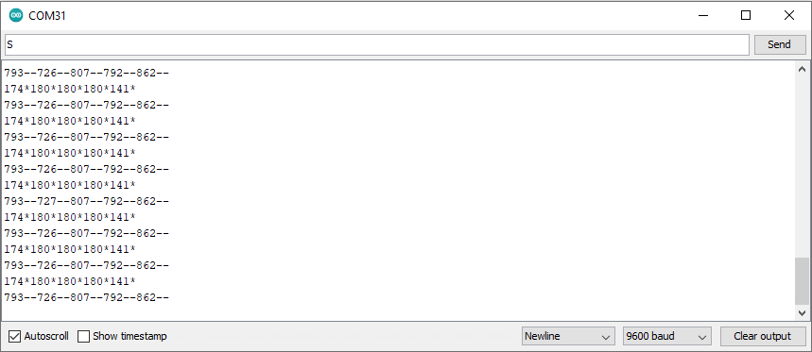

*Fig 12: Flexi sensor calibration*

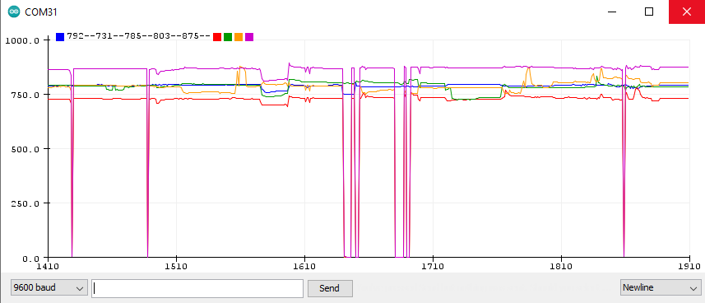

*Fig 13: Flexi sensor graph*

# Critical Discussion

## Design

Servo motors control how the fingers move. Each finger features five HK15298 servo motors that can pull between 4.8 and 7.4 volts, although just 5 volts are necessary to move the finger in the appropriate direction. According to the equation P=VI, each motor uses an average current of 0.5 to 1 ampere, which translates to a power consumption of 2.5 to 5 watts per motor.

To regulate the bionic hand's fingers' flexibility and grip power, a pulley is necessary. It permits the transmission of force from a motor to the tendons, which are attached to the fingers and enable pulling or releasing. The tendons get controlled force transmission from the pulley system. The pulley needs to be 3D printed so that we can calculate the circumference by determining the radius of each pulley. Once we have the circumference, we can then figure the arc length. The Arduino Sensor shield, which will be attached to the motor, may then be programmed to rotate the pulleys by the arc length after the arc length has been determined.

The hardware parts were created utilizing a 3D printing system that was readily available and cost-free at the institution. For a number of reasons, we opted to 3D print the components rather than buy ready-made ones. First off, 3D printing makes it possible to customize and be flexible with designs. This was notably useful for product and prototype development where needed design changes. Second, 3D printing might be more economical for smaller manufacturing runs.

Last but not least, in some cases, specialty parts might not be widely available on the market, making 3D printing the only practical option for producing those parts. The parts had to be repeatedly printed due to a problem we ran across during the printing process. Mechanical problems caused the printing to stop abruptly in the middle, which was the cause of this.

The prototype is not wireless for many reasons and is tethered to every source. Many people believe that wireless communications are less dependable and secure than those using wired connections. This is because wired connections create a physical connection between devices, enabling data to be transferred without external device interference. Additionally, they offer faster data transmission rates than wireless connections, which is particularly advantageous for high-speed data transfer applications. A wired network's essential hardware often lasts longer than a wireless network. Wired connections can therefore offer a more stable and secure connection with less performance variation.

## Feasibility

Feasibility can cover a range of topics involving:

1. Technical Feasibility: During the project, we encountered challenges in calibrating the glove and 3D printing the entire hand. Multiple iterations were necessary for each part, including the fingertips, until we achieved a successful assembly of all components into a cohesive piece.

2. Economic Feasibility: Our project operated within a strict budget, requiring careful allocation of resources. We diligently considered the cost of components, ensuring an optimal balance between cost-effectiveness and efficiency. This allowed us to select suitable components that met our budgetary constraints while maintaining performance standards.

3. Operational Feasibility: The practicality of each device, such as the motor turning ratio, played a crucial role in determining the feasibility of our hand. We evaluated various motor options, considering factors like their available rotation range. We ultimately settled on motors with a 180-degree rotation, as this proved to be the most suitable choice given the length of the wires we utilized.

4. Ethical and Social Feasibility: It is important to consider the broader implications of our project. We can explore the ethical considerations surrounding user privacy, data security, and potential societal impacts. Additionally, we can examine the social acceptance and potential benefits of our teleoperation system, such as its potential to enhance accessibility and improve the quality of life for individuals with limited hand mobility or in the military as a reliable to defuse explosives.

By addressing these feasibility aspects, including ethical and social considerations, we can evaluate the practicality and viability of our project while considering the impact on individuals and society as a whole.

# Statement on Achievements

The bionic hand has a meticulously engineered mechanical design that copies the structure and range of motion of a human hand. It has precise actuation mechanisms built in, like servo motors, that allow for precise finger control and coordinated motions. The user receives the best possible functionality, adaptability, and durability because of the mechanical design. The prototype's grasping and manipulating abilities are impressive. It can precisely and firmly grasp objects of different weights, sizes, and shapes. The bionic hand's ability to adapt its grip to fit various object geometries is made possible by the use of finger joints and flexible materials, which increases versatility and improves the user experience.

The prototype's user-friendly interface and control system enable simple operation of the bionic hand. This includes incorporating flex sensors and feedback to understand user commands and deliver real-time data. The control system makes sure that the movements are accurate and quick, giving the user a seamless interaction with the bionic hand. The bionic hand prototype also acts as an effective proof of concept, confirming the feasibility of the design and showcasing its capabilities. Testing of force, accuracy, and object manipulation have all been done by the team as part of performance evaluations. These evaluation's findings attest to the bionic hand prototype's usefulness and potential.

The team has maintained thorough documentation for the duration of the project, which includes technical drawings, assembly instructions, and reports. These documents describe the testing procedures, component integration, installation process, and design justification. When replicating the prototype and comprehending the development process, these documents are invaluable resources.

# Recommendations

According to the current state of bionic hands, people have the potential to restore motor functions and enhance the quality of life for people who work from far distances. The dexterity, sensory feedback, and natural control of these devices, however, could still be improved. Prioritizing the development of affordable manufacturing methods and simplified production processes is essential to ensure the widespread distribution and accessibility of bionic hands.

Bionic hands can free up human workers from many tasks that could cause injury, such as:

The bionic hand can and will be very helpful in the military because it can complete tasks like defusing a bomb without the help of a human, which will save time and effort. The medical field can also greatly benefit from the use of bionic hands, which can perform robotic surgery under human control from a distance, saving the lives of many people from various countries who do not have access to medical experts. In other words, it encourages direct therapy without requiring physical appearance in these locations.

Robotic hands can also be useful equipment in the manufacturing and industrial sectors. It can be used for complex operations or tasks that call for precise movements, like assembling components. The bionic hands can work alongside humans or independently in situations that might be dangerous or physically demanding for human workers. These hands are ideal for simplifying production processes and boosting productivity because of their speed, accuracy, and capacity for repeating tasks repeatedly.

# Attainment of Objectives

The achievement of objectives is one of the most key aspects of any project's success. All project goals, including those listed below, have been achieved in accordance with the plan that was established before the project started.

The project's initial goal was to print a hand using a 3D printer in order to capture the overall concept and future appearance of the project. The next step was to collect all the components, including flex sensors, servo motors, fishing line, jumping wires, perfboard, and an Arduino board, in order to begin integrating them into the 3D-printed hand.

The team then began working on the next goal, which was the integration of the flex sensors on the Perfboard. The team decided to integrate the flex sensors on the perfboard in order to save space and cut down on the number of wires used on the Arduino board. After that, the team has begun attaching servo motors and fishing line to the 3D-printed hand in order to enable the fingers to rotate whenever the servo motors do.

The next objective was to attach the flex sensors and the perfboard to a leather glove so that users could use it to control the 3D-printed hand's fingers. When the flex sensors rotated from the glove, the fingers would also rotate simultaneously. Following that, the final objective of the project is to connect everything. To do this, the 3D-printed hand and the glove with the flex sensors will both be connected to an Arduino board. This will then power up all the components.

# Appendix

## Appendix A: Gantt Chart

### 11.1.1 Autumn Semester 2022

### 11.1.2 Winter Semester 2023

### 11.1.3 Spring Semester 2023

## Appendix B: Minutes of Meeting

Over the past three semesters, the team has conducted more than 23 meetings that are related to the discussion of our project and how to work and execute all project objectives. These meetings helped all the team members to share their opinions and ideas to make it a successful project in the end. For this semester, 9 meetings have been conducted between the team members.

Minutes of meeting 16

Robotic Hand Project

Faculty of Engineering and Information Sciences

Date: 19 April 2023

Time: 21:00PM – 22:00PM

Place: Online meeting.

Topic: Project progress

Members Present:

|  |  |  |
| --- | --- | --- |
| No | Student name | Student ID number |
| 1. | Clayton D’Gama | 7242293 |
| 2. | Saharsh Madassery | 6922764 |
| 3. | Suraksha Kotte | 6996656 |
| 4. | Mohamed Abuklal | 5902514 |

|  |  |
| --- | --- |
| No | Subject |
| 1. | Discussion |
|  | * Requesting flex sensors. * Decided to reprint the hand using 3D-printer. |

Minutes of meeting 17

Robotic Hand Project

Faculty of Engineering and Information Sciences

Date: 28 April 2023

Time: 19:00PM – 19:30PM

Place: Online meeting.

Topic: project progress.

Members Present:

|  |  |  |
| --- | --- | --- |
| No | Student name | Student ID number |
| 1. | Clayton D’Gama | 7242293 |
| 2. | Saharsh Madassery | 6922764 |
| 3. | Suraksha Kotte | 6996656 |
| 4. | Mohamed Abuklal | 5902514 |

|  |  |
| --- | --- |
| No | Subject |
| 1. | Discussion |
|  | * Discussed about the upcoming presentations and reports. |

Minutes of meeting 18

Robotic Hand Project

Faculty of Engineering and Information Sciences

Date: 10 May 2023

Time: 21:00PM – 21:45PM

Place: Online meeting.

Topic: Mid-project discussion.

Members Present:

|  |  |  |
| --- | --- | --- |
| No | Student name | Student ID number |
| 1. | Clayton D’Gama | 7242293 |
| 2. | Saharsh Madassery | 6922764 |
| 3. | Suraksha Kotte | 6996656 |
| 4. | Mohamed Abuklal | 5902514 |

|  |  |
| --- | --- |
| No | Subject |
| 1. | Discussion |
|  | * Discussion regarding the Mid-project demo. * Discussion about preparing the hand for the demo. |

Minutes of meeting 19

Robotic Hand Project

Faculty of Engineering and Information Sciences

Date: 20 May 2023

Time: 17:00PM – 18:00PM

Place: Online meeting.

Topic: Mid-project presentation.

Members Present:

|  |  |  |
| --- | --- | --- |
| No | Student name | Student ID number |
| 1. | Clayton D’Gama | 7242293 |
| 2. | Saharsh Madassery | 6922764 |
| 3. | Suraksha Kotte | 6996656 |
| 4. | Mohamed Abuklal | 5902514 |

|  |  |
| --- | --- |
| No | Subject |
| 1. | Discussion |
|  | · Distributing the parts between all team members. |

Minutes of meeting 20

Robotic Hand Project

Faculty of Engineering and Information Sciences

Date: 05 June 2023

Time: 20:00PM – 21:00PM

Place: Online meeting.

Topic: Project progress.

Members Present:

|  |  |  |
| --- | --- | --- |
| No | Student name | Student ID number |
| 1. | Clayton D’Gama | 7242293 |
| 2. | Saharsh Madassery | 6922764 |
| 3. | Suraksha Kotte | 6996656 |
| 4. | Mohamed Abuklal | 5902514 |

|  |  |
| --- | --- |
| No | Subject |
| 1. | Discussion |
|  | · Discussion regarding the upcoming presentations and reports. |

Minutes of meeting 21

Robotic Hand Project

Faculty of Engineering and Information Sciences

Date: 13 June 2023

Time: 20:00PM – 21:00PM

Place: Online meeting.

Topic: Final-project presentation.

Members Present:

|  |  |  |
| --- | --- | --- |
| No | Student name | Student ID number |
| 1. | Clayton D’Gama | 7242293 |
| 2. | Saharsh Madassery | 6922764 |
| 3. | Suraksha Kotte | 6996656 |
| 4. | Mohamed Abuklal | 5902514 |

|  |  |
| --- | --- |
| No | Subject |
| 1. | Discussion |
|  | · All parts of the presentation needed have been distributed to each member of the team members. |

Minutes of meeting 22

Robotic Hand Project

Faculty of Engineering and Information Sciences

Date: 17 June 2023

Time: 20:00PM – 21:00PM

Place: Online meeting.

Topic: Final-project Demonstration video.

Members Present:

|  |  |  |
| --- | --- | --- |
| No | Student name | Student ID number |
| 1. | Clayton D’Gama | 7242293 |
| 2. | Saharsh Madassery | 6922764 |
| 3. | Suraksha Kotte | 6996656 |
| 4. | Mohamed Abuklal | 5902514 |

|  |  |
| --- | --- |
| No | Subject |
| 1. | Discussion |
|  | · Integrating all the projects components together for the final video. |

Minutes of meeting 23

Robotic Hand Project

Faculty of Engineering and Information Sciences

Date: 23 June 2023

Time: 16:00PM – 17:30PM

Place: Online meeting.

Topic: Final Report.

Members Present:

|  |  |  |
| --- | --- | --- |
| No | Student name | Student ID number |
| 1. | Clayton D’Gama | 7242293 |
| 2. | Saharsh Madassery | 6922764 |
| 3. | Suraksha Kotte | 6996656 |
| 4. | Mohamed Abuklal | 5902514 |

|  |  |
| --- | --- |
| No | Subject |
| 1. | Discussion |
|  | · All parts of the report have been distributed to each member of the group. |

Minutes of meeting 24

Robotic Hand Project

Faculty of Engineering and Information Sciences

Date: 13 June 2023

Time: 20:00PM – 21:00PM

Place: Online meeting.

Topic: Innovation Fair preparation.

Members Present:

|  |  |  |
| --- | --- | --- |
| No | Student name | Student ID number |
| 1. | Clayton D’Gama | 7242293 |
| 2. | Saharsh Madassery | 6922764 |
| 3. | Suraksha Kotte | 6996656 |
| 4. | Mohamed Abuklal | 5902514 |

|  |  |
| --- | --- |
| No | Subject |
| 1. | Discussion |
|  | · Discussion about how to improve our project for the Innovation Fair. |

## Appendix C: Division of Labor

|  |  |  |  |  |
| --- | --- | --- | --- | --- |
| Name | Parts | Start Date | Finish Date | Working Hours |
| Clayton D’Gama | 1 - Testing procedure  2 - Critical Discussion of design and Feasibility  3 – Power and torque calculations  4 – Critical discussion  5 – Results/outcomes | 5thJul | 6th Jul | 15 hours |
| Saharsh Madassery | 1 - Presentation of Results, analysis and discussion  2 - Critical Discussion of design and Feasibility  3 - flex sensor movement graphs  4 - Methodology followed  5 - Iteration objectives and goals | 5th Jul | 6th Jul | 15 Hours |
| Suraksha Kotte | 1 - Design details  2 - Flex sensor flowcharts/  circuit  3 - Report structure and editing  4 - Team roles/action taken  5 - Challenges faced  6 - Challenges overcome  7- Gantt Chart | 5th Jul | 6th Jul | 15 Hours |
| Mohamed Abuklal | 1 - Quality od Executive Brief  2 - Definition of project/Clarity of objectives/deliverable  3 - Statement on Achievements  4 - Recommendations  5 - Attainment of Objectives  6 - Appendix | 5th Jul | 6th Jul | 13 Hours |

## Appendix D: Software Code

#include <Servo.h>

//creating servo object

Servo s1; //defining servo

Servo s2; //defining servo

Servo s3; //defining servo

Servo s4; //defining servo

Servo s5; //defining servo

int f1 = A0; //pin A0 to read analogue input thumb

int f2 = A1; //pin A1 to read analogue input middle

int f3 = A2; //pin A2 to read analogue input index

int f4 = A3; //pin A3 to read analogue input pinkey

int f5 = A4; //pin A4 to read analogue input ring

;

void setup()

{

Serial.begin(9600);

s1.attach(2); //attaching servo to used pin 2

s2.attach(3); //attaching servo to used pin 3

s3.attach(4); //attaching servo to used pin 4

s4.attach(5); //attaching servo to used pin 5

s5.attach(6); //attaching servo to used pin 6

}

void loop()

{

//two int variabled declared //thumb

int f1_position; //stores values used for flex sensor reading

int s1_position; //stores values for the servo motor position

f1_position = analogRead(f1); //reads the analog value from flex sensor connected to pin flex1and assigns it to flex1_position

s1_position = map(f1_position, 730, 795, 0,180); //maps the reading from flex1_position from range 840-900 to range 180-0

s1_position = constrain(s1_position, 0, 180); //ensures calue of flex1_position remains in range 0-180

s1.write(s1_position);// position of servo motor matched on found specified range

int f3_position; // index

int s3_position;

f3_position = analogRead(f3);

s3_position = map(f3_position, 725, 795, 0, 180);

s3_position = constrain(s3_position, 0, 180);

s3.write(s3_position);

int f2_position; //middle

int s2_position;

f2_position = analogRead(f2);

s2_position = map(f2_position, 690, 720, 0, 180);

s2_position = constrain(s2_position, 0, 180);

s2.write(s2_position);

int f5_position; //ring

int s5_position;

f5_position = analogRead(f5);

s5_position = map(f5_position, 780, 884, 0, 180);

s5_position = constrain(s5_position, 0, 180);

s5.write(s5_position);

int f4_position; // pinkey

int s4_position;

f4_position = analogRead(f4);

s4_position = map(f4_position, 735,778, 0, 180);

s4_position = constrain(s4_position, 0, 180);

s4.write(s4_position);

// testing code on serial monitor

Serial.print(s1_position);

Serial.print("--");

Serial.print(s2_position);

Serial.print("--");

Serial.print(s3_position);

Serial.print("--");

Serial.print(s4_position);

Serial.print("--");

Serial.print(s5_position);

Serial.println("--");

Serial.print(f1_position);

Serial.print("--");

Serial.print(f2_position);

Serial.print("--");

Serial.print(f3_position);

Serial.print("--");

Serial.print(f4_position);

Serial.print("--");

Serial.print(f5_position);

Serial.println("--");

delay(300);

}

# References

[1]

“inmoov hand 3d model - Google Search,” Google.com, 2013. https://www.google.com/search?q=inmoov+hand+3d+model&rlz=1C5CHFA_enAE942AE942&sxsrf=ALiCzsZpD99O-3N6VM_KYb61ha8_95LnmA:1670402917951&source=lnms&tbm=isch&sa=X&ved=2ahUKEwjAkrnkj-f7AhWpTKQEHdr_CcsQ_AUoAXoECAMQAw&biw=1309&bih=746&dpr=2.2#imgrc=GwxocziKMip43M (accessed Dec. 07, 2022).

‌[2]

“inmoov hand 3d model - Google Search,” Google.com, 2013. https://www.google.com/search?q=inmoov+hand+3d+model&rlz=1C5CHFA_enAE942AE942&sxsrf=ALiCzsZpD99O-3N6VM_KYb61ha8_95LnmA:1670402917951&source=lnms&tbm=isch&sa=X&ved=2ahUKEwjAkrnkj-f7AhWpTKQEHdr_CcsQ_AUoAXoECAMQAw&biw=1309&bih=746&dpr=2.2#imgrc=-DLK_fpPL27m7M (accessed Dec. 07, 2022).

[3]

“V Model SDLC: Verification and Validation Model |Professionalqa.com,” *Professionalqa.com*, 2019. https://www.professionalqa.com/v-model (accessed Jul. 06, 2023).

**[4]**

“InMoov - home - InMoov,” InMoov, Nov. 29, 2022. https://inmoov.fr/ (accessed Dec. 07, 2022).